**FIELDWORK ON AT KASENYI FISH LANDING SITE**

**For any one fieldwork study you have conducted on a fish landing site**

1. **State the topic of study.**

The Growth and Development of Kasenyi fish landing site on the northern shore of Lake Victoria, in Wakiso District.

1. **Outline the objectives of study.**

* To find out the location of Kasenyi fish landing site.
* To find out the historical background of Kasenyi fish landing site
* To find out the factors for the location and growth of Kasenyi fish landing site
* To find out the physical features around Kasenyi fish landing site
* The find out the landuse activities around Kasenyi fish landing site
* To find out the influence of Kasenyi fish landing site on the surrounding areas
* To find out the fish species landed at Kasenyi fish landing site
* To find out the problems facing Kasenyi fish landing site
* To find out the solutions to the problems facing Kasenyi fish landing site
* To find out the future prospects of Kasenyi fish landing site.

1. **Methods of data collection**

* **Observation**
* **Interview**
* **Recording**
* **Sketching**
* **Literature review**
* **Map orientation**
* **Measurement**
* **Pacing**
* **Questionnaire**

**4.Tools needed**

* **Hoe**
* **Meter ruler**
* **Pens**
* **Pencils**
* **Voice recorder**
* **Video recorder**
* **Camera**

**5.Explain the preparations you made before going for fieldwork**

**OR, explain the steps you took before going for fieldwork**

**OR, explain the pre-field activities carried out before going for fieldwork.**

**OR, describe the activities you carried out before going for fieldwork.**

**OR, describe how you organized your fieldwork study.**

* Our teacher identified the area of study and went for a pilot study at Kasenyi fish landing site to find out whether it would be possible to carry out fieldwork and get permission from the management of Kasenyi fish landing site.
* We chose the topic of study and it was ‘The Growth and Development of Kasenyi fish landing site on the northern shore of Lake Victoria, in Wakiso District’.
* We formulated the objectives of study and they included; To find out the location of Kasenyi fish landing site, To find out the historical background of Kasenyi fish landing site.
* We selected the methods to be used during fieldwork and these included observation, interviewing and measurement.
* We selected the tools to be used during fieldwork and these included pens, pencils, books, measuring tape and base map.
* We sought permission from the school administration to allow us carry out fieldwork.
* Our teacher organized us in groups of five students to ensure group study.

**5.Draw a transect/transverse/relief section/cross-section of the area studied and on it mark and name physical features and landuse activities.**

A TRANSECT ACROSS KASENYI LANDING SITE FROM BENDEGERE HILL TO LAKE VICTORIA SHOWING PHYSICAL FEATURES AND LANDUSE ACTIVITIES

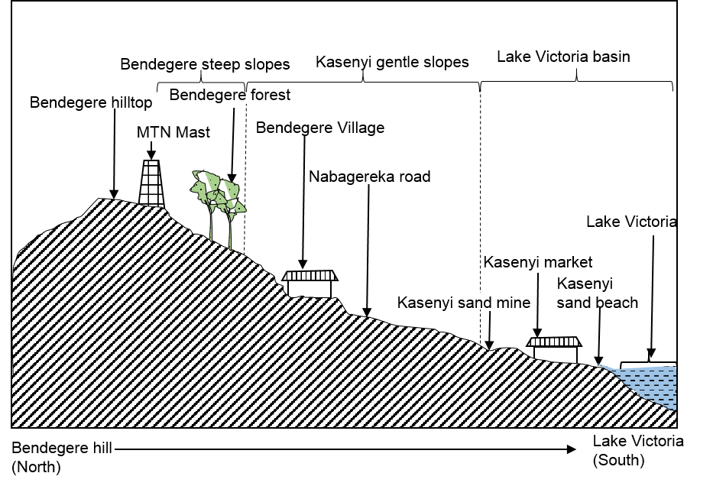

1. **Draw a sketchmap of the area studied and on it mark and name physical features and landuse activities.**

A SKETCHMAP OF KASENYI FISH LANDING SITE AND THE SURROUNDING AREAS SHOWING PHYSICAL FEATURES AND LANDUSE ACTVITIES.

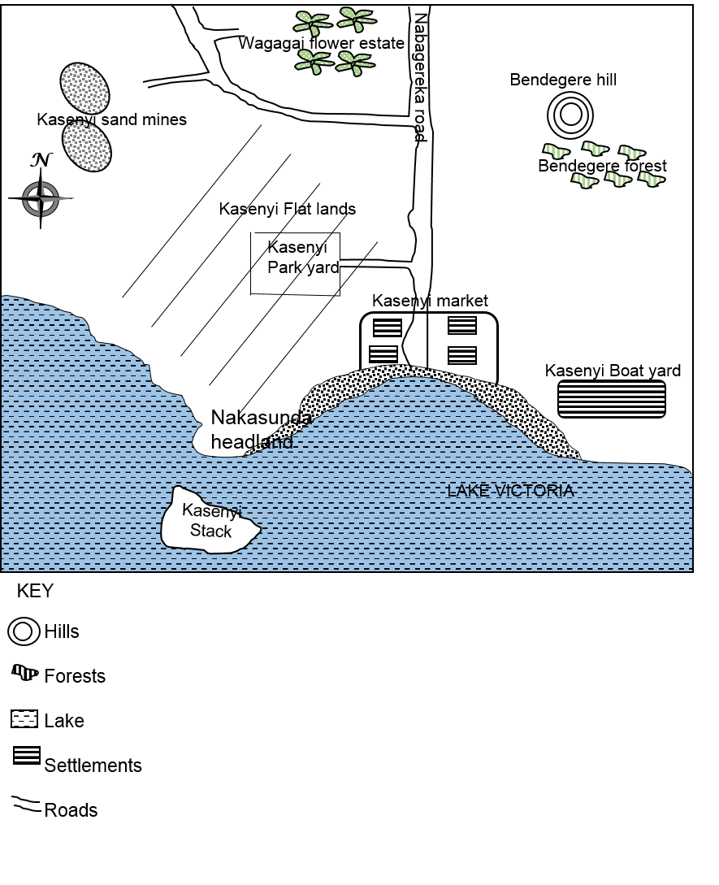

1. **Draw a panoramic view of the area studied and on it mark and name physical features and landuse activities.**

A PANORAMIC VIEW OF THE AREA AROUND KASENYI FISH LANDING SITE DRAWN FROM NAKASUNDA HEADLAND SHOWING PHYSICAL FEATURES AND LANDUSE ACTIVITIES

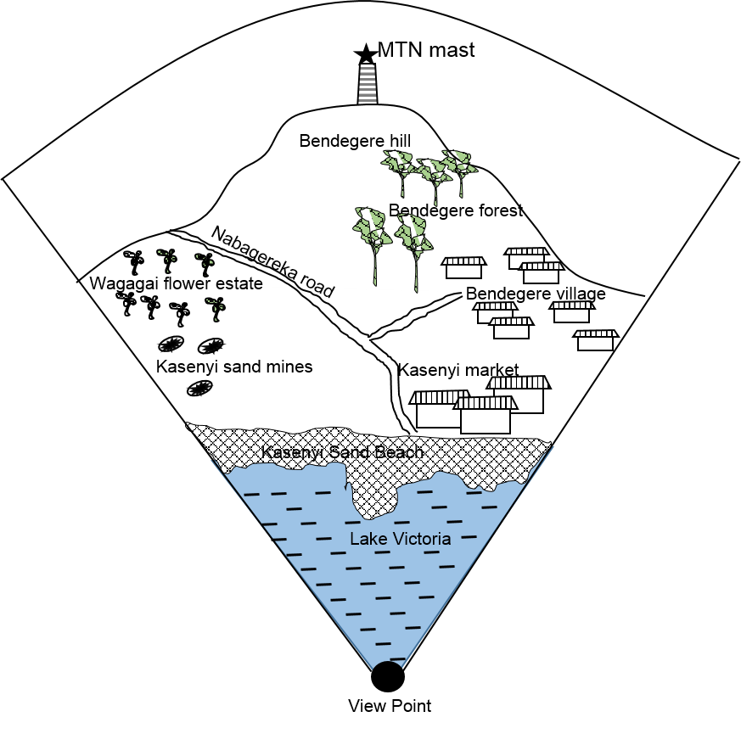

1. **Describe the steps you took to collect information from the field**

**Or, describe the activities you carried out during fieldwork**

**Or, explain the techniques you used during fieldwork**

**Or, describe the methods you used to collect the information in the field.**

* I used observation method. This involved using eyes with the help of other senses to see geographical phenomena in the field and sort out information about them. Using eyes, I saw physical features like Bendegere hill in the north of Kasenyi fish landing site.
* I used interviewing method. It involves a face-face interaction between the researchers and respondents in the field whereby the researcher asked oral questions and the respondents gave oral answers. Using the interview guide, I asked Mr. Muyanja Peter the fieldwork guide the problems facing Kasenyi fish landing site and he told me that there is a problem of dangerous aquatic animals like crocodiles that claim the lives of fishermen.
* We used Questionnaire method. This involved use of predetermined questions to collect information about geographical phenomena where the researcher sends written questions for a respondent to give written answers. I wrote and sent the following questions to Mr. Muyanja Peter the fieldwork manager and he gave us answers in written form.

Where is Kasenyi fish landing site located? It is located in southeast of AbaitaAbabiri a nearest trading centre. It is in Bendegere L.C.I, Nkumba parish, Katabi Sub County, Busiiro county of Wakiso district.

* I used measurement/measuring. This involved the use of calibrated and non-calibrated instruments to establish/investigate size, weight, area etc. of geographical features in the field. I stretched a tape measure and found the distance from Kasenyi market to Kasenyi Pier which was 100 metres.
* I used Pacing. This involved the use of strides to estimate distance of the geographical features. Using strides, I estimated the distance from Kasenyi market to Kasenyi pier, which was 120 strides.
* I used sampling. This involved taking part of the whole population to represent the whole/rest. Using a hoe and spade, I picked part of the soil from Kasenyi sand beach and found out that it was sandy soil.
* I used recording. This involved writing/jotting/noting down of information got in the field. Using a pen and paper, I wrote down the problems facing fishermen at Kasenyi fish landing site which included dangerous aquatic animals, shortage of accommodation and food.
* We used field sketching. This is the technique of obtaining information from the field by drawing sketchmaps, transects and panoramas. I used a pencil and book and drew the sketchmap of the area around Kasenyi fish landing site showing physical features and landuse activities as seen below (draw and show some few features like the one above).
* We used map orientation. This involved alignment/rotating/turning the survey map/base map so that the features on the base map tally/match with features on the ground. We turned the base map of Entebbe while standing at Nakasunda headland until Kasenyi landing site on the base map was matching with that on the ground and found out that Kasenyi is in north of Lake Victoria.
* We used analysis of existing information/library research/documentary review/literature review/documentation. This is a method of data collection whereby the researcher gets information from existing records/secondary sources and compares it with what is in the field at the time of study. We read about historical background of Kasenyi fish landing site in the research report by Matovu Francis and found out that the name Kasenyi was a result of the eroded fine sand along the shoreline and it has been used since the early 1960s.

1. **Explain the merits of using the above methods**

NB. Use past tense, tie the merit to a method and add some explanation.

* Using observation method, I got first hand information since geographical features were seen directly
* Observation was time saving since a large field was covered in a short time.
* Observation was cheap because it did not involve expenditure.
* Interviewing enabled me getting the required data on the spot.
* Interviewing enabled me to obtain invisible information like historical background.
* Interviewing was very flexible because questions were modified during the interview.
* Questionnaire method was time saving as many respondents were reached in a short time.
* Reliable data was got while using questionnaire method since respondents answered independently.
* Questionnaire method was easy to administer since it reached respondents in different ways.
* Measurement was flexible since different tools and techniques were used.
* Measurement enabled making predictions about the phenomena investigated.
* Firsthand information was obtained using measurement since tools were used.
* Sampling was time saving since few entities/items were chosen to represent the rest.
* Unbiased data was got using sampling because I came into contact with the phenomena.
* Sampling allowed generalization to be made about other similar phenomena.
* Using documentary review, information was provided in a short period of time.
* Accurate information based on research was obtained using documentary review/documentation
* Documentary review helped in getting the background information about the topic of study

1. **Explain the demerits of using the above methods.**

**OR, explain the problems/challenges you encountered while using the above methods during fieldwork**

**OR, explain the limitations of using the above methods during fieldwork study.**

**OR**

**Explain the problems/challenges you encountered during fieldwork**

**OR, explain the limitations of your fieldwork study.**

* I faced the problems of language barrier while using interviewing since my respondents the fishermen only knew Luganda and therefore I failed to get the problems facing fishermen at Kasenyi fish landing site.
* We faced the problem of uncooperative respondents while using interviewing at Kasenyi market and therefore, we failed to get the historical background of Kasenyi market.
* We faced a problem of loss of questionnaires while using questionnaire method due to disappearance of respondents and therefore we failed to get information on the historical background of Kasenyi fish landing site.
* We faced the problem of physical obstruction by Bendegere forest while using observation method and therefore we failed to identify the landuse types in Bendegere village.
* We faced the problem of inaccessibility due to the presence of Kasenyi forest while using observation method due to the presence of Bendegere forest and therefore we failed to see the landuse activities in Bendegere village
* We faced the problem of noise pollution by Kasenyi boat factory while using interviewing/recording and therefore, we failed to hear/note down the problems facing Kasenyi boat factory.
* We faced the problem of sudden weather changes due to heavy downpour while using recording, which destroyed our writing materials and therefore we failed to write down the future prospects of Kasenyi fish landing site

1. **Explain the skills you obtained from your fieldwork study.**

NB. Skills are obtained from the methods used.

* I gained the skill of observation by using my eyes to see physical features for example Bendegere hill north east of kasenye fish landing site .
* We gained the skill of interviewing by asking respondents oral questions and they gave us oral answers for example we asked Mr. Mubiru the location of Bendegere hill and he told me that it is found in Nkunba Parish, Wakiso District.
* We gained the skill of measuring by stretching the tape measure to find the distance from Kasenyi market to the pier which was 50 metres.
* We gained the skill of sampling by using a hoe to pick part of the soil from kasenyi beach which we found out that it was mainly sandy soil.
* I gained the skill of recording by using a pen and paper to write down information in the field for example I wrote down physical features around kasenyi fish landing site like Bendegere hill north east of kasenye fish landing site
* I gained the skill of field sketching by drawing the sketch map of the area around kasenyi fish landing site showing physical features and landuse activities as seen below (draw it and show some features).

1. **Describe the follow up activities carried out after fieldwork**

**Or, what were the post-field activities carried out during the study**

**Or, explain how you processed data during the study.**

* We presented our data collected by the different groups for example group 1 presented the location of Kasenyi fish landing site i.e. Katabi Sub-county, Wakiso District.
* We compared data collected by the various groups for example concerning the distance from Kasenyi market to Kasenyi pier and we finally concluded that it was 100metres.
* We reorganized data collected only included the required information to be compiled following our topic and objectives of study.
* We polished our field sketches by redrawing the sketchmap around Kasenyi fish landing site and included Nakasunda headland which was missing.
* We wrote a fieldwork report concerning what we studied at Kasenyi fish landing site, how we studied it and the results obtained from the study.
* We drew conclusions from the field by giving geographical relationships. For example we concluded that the presence of Bendegere hilltop has encouraged the establishment of MTN telecommunication masts due to high altitude which ensures easy transmission of signals.
* We made recommendations to the people of Kasenyi fish landing sites for example we advised farmers on Bendegere hill to carry out terracing so as to control soil erosion.
* We disseminated the findings of the study to the relevant authorities for example one of our fieldwork report was handed over to the manager of Kasenyi fish landing site

1. **Explain the conclusions you made after fieldwork study**

**OR, explain the significance of the fieldwork study**

**OR, to what extent was the fieldwork study geographical**

**OR, what was the geographical significance of the fieldwork study?**

**OR, what were the outcomes/results of the fieldwork study?**

**OR, how did the fieldwork study help you to understand the geography of the area?**

**OR, how was the fieldwork study a sample of the environment?**

**Physical- physical relationships**

* The presence Bendegere hill in the north of Kasenyi landing site has encouraged the growth of Bendegere natural forest because of the presence of deep fertile soils.
* The presence of Lake Victoria in the south of Kasenyi fish landing site has favoured the growth of Kasenyi papyrus vegetation due to water logging conditions.

**Physical-human relationships**

* The presence of gentle slopes of Bendegere hill in the north of Lake Victoria has encouraged settlement at Bendegere village due to easy construction of houses
* The presence of Lake Victoria in the South of Kasenyi fish landing site has encouraged water transport due to the presence of water.
* The presence of Bendegere forest in the north of Kasenyi fish landing site has encouraged the growth of Kasenyi boat making factory due to the presence of commercial tree species like Mvule.

**Human-human relationships**

* The presence of Nabagereka road in the north of Kasenyi fish landing site has encouraged settlement at Kasenyi due to easy accessibility.
* The presence of Kasenyi boat making factory in the north of Kasenyi fish landing site has attracted dense settlement at Kasenyi due to provision of employment opportunities.
* The presence of dense settlement at Kasenyi has encouraged the growth of Kasenyi market because of provision of ready market for goods

1. **Explain the relationship between the physical environment and landuse activities in the area studied**

* The presence of gentle slopes of Bendegere hill in the north of Kasenyi fish landing site has encouraged settlement at Bendegere due to easy construction of houses
* The presence of Lake Victoria in the south of Kasenyi fish landing site has encouraged water transport due to the presence of water.
* The presence of fertile soils of Bendegere hill in the north of Kasenyi fish landing site has encouraged the growth of coffee and bananas in Bendegere village since these crops require deep fertile soils to grow well.
* The presence of Bendegere forest in the north of Kasenyi fish landing site has encouraged lumbering due to the presence of valuable tree species like Mahogany.

1. **Explain the relationship between physical features and landuse activities in the area studied.**

* The presence of gentle slopes of Bendegere hill in the east of Kasenyi fish landing site has encouraged settlement at Bendegere village due to easy construction of houses.
* The presence of Lake Victoria in the South of Kasenyi fish landing site has encouraged water transport due to the presence of water.
* The presence of Bendegere forest in the north of Kasenyi fish landing site has encouraged lumbering due to the presence of valuable tree species like Mahogany.

1. **Explain the relationship between relief and landuse activities in the area studied.**

* The presence of gentle slopes of Bendegere hill in the north of Kasenyi fish landing site has encouraged settlement at Bendegere due to easy construction of houses
* The presence of Bendegere hilltop has encouraged the establishment of MTN telecommunication masts due to high altitude which ensures easy transmission of signals.
* The presence of Lake Victoria basin has encouraged water transport due to the presence of water.
* The presence of steep slopes of Bendegere hill in the north of Kasenyi fish landing site has encouraged stone quarrying due to the presence of outcrop rocks
* The presence of flat lands of Kasenyi in the north of Kasenyi fish landing site has encouraged the construction of Nabagereka road due to low cost of construction.

1. **Assess the impact of the fish landing site on the environment**

**OR, Assess the impact of the fish landing site on the development of the surrounding areas.**

NB. Give both positive and negative effects giving an example in terms of placename/direction.

**Positive impacts include;**

* It has encouraged growth and development of Kasenyi trading centre in the north of Kasenyi fish landing site because of increased population.
* It has facilitated the development of infrastructure like Nabagereka road in the north of Kasenyi fish landing site.
* It has provided market for goods sold in Kasenyi market for example agricultural products like potatoes and domestic items.
* It has provided employment opportunities to the people for example fishermen in Lake Victoria in the South of Kasenyi fish landing and shop attendants in Kasenyi market in the north of Kasenyi fish landing site
* It has encouraged the development of industries for example Kasenyi boat making factory in the north of Kasenyi fish landing site.
* It is a source of government revenue through taxing people employed for example as fishermen in Lake Victoria south of Kasenyi fish landing site and business men in Kasenyi market in the North of Kasenyi fish landing site.

**Negative effects include;**

* It has led to pollution of water, land and air from industries for example Kasenyi boat factory in the north of Kasenyi fish landing site.
* It has led to urban related problems like prostitution and robbery in Kasenyi trading centre due to increased population
* It has led to deforestation due to infrastructural development for example Kasenyi forests were destroyed to establish Kasenyi market.
* It has led to competition for labour with other sectors like agriculture in Nkumba and Bendegere village living these sectors underdeveloped.
* It has led to increased school drop out to join fishing activities for example from Bendegere village and Nkumba.
* It has led to rural-urban migration with its negative effects for example from Nkumba to Kasenyi fish landing site

1. **Explain the impacts of the growth of the landing site on the physical environment.**

NB. Give both positive and negative effects giving an example in terms of place name/direction on every point

Positive effects include;

* Afforestation on Bendegere hill north of Kasenyi fish landing site has promoted the modification of the local temperatures through releasing moisture to the atmosphere.
* Application of manure in Bendegere village north of Kasenyi fish landing site has helped to improve soil fertility.
* Contour ploughing on Bendegere hill has helped in controlling soil erosion.
* Afforestation in in Bendegere hill has helped in increasing the green vegetation cover.

Negative effects include

* Lumbering in Bendegere forest north of Kasenyi fish landing site has led to destruction of vegetation cover
* Industrialization at Kasenyi boat factory north of Kasenyi fish landing site has led to environmental pollution from the wood dust which has affected human health.
* Settlement on Bendegere hill north of Kasenyi fish landing site has led to destruction of Bendegere forest leading to loss of vegetation cover
* The construction of Nabagereka road in the north of Kasenyi fish landing site has led to destruction of Kasenyi forest leading to destruction of vegetation cover.
* Stone quarrying on Bendegere hill north of Kasenyi fish landing site has led to destruction of landscape by creating depressions.

1. **Explain the problems faced by the people using the fish landing site.**

NB. Explain how a problem leads to a problem.

* Poor sanitation leading to diseases like cholera and dysentery which have affected human life.
* Remoteness of the area of Kasenyi landing site with poorly developed roads has discouraged movement of goods by Kasenyi traders to the landing site.
* Limited fish stock as a result of overfishing in Lake Victoria has led to low fish catch leading to low levels of income.
* Perishability of the fish due to traditional fish preservation methods like smoking which lead to losses.
* Price fluctuation due to over production has discouraged fishermen in Lake Victoria to produce more fish.
* Low incomes among fishermen in Lake Victoria leading to use of poor methods of fishing which .are highly inefficient leading to low output.
* Limited research conducted by the fishermen in Lake Victoria has led to low fish catch
* Rugged terrain for example due to Bendegere hill has discouraged the construction of roads to deliver fish to the market centres.
* Siltation of Lake Victoria has led to reduction in breeding grounds for fish leading to low fish catch.
* Insecurity due to pirates in Lake Victoria and robbers in Kasenyi Trading centre who distabilise peace.
* Changes in water levels leading to fluctuation in fish catch hence leading to fluctuation in incomes.

1. **Describe the recommendations you made to the people using the fish landing site.**

NB. Give solutions to showing problem and solution

* We advised the fishermen at Kasenyi fish landing site to carry out market research to expand the market for fish.
* We advised the police force at Kasenyi police station to carry out more operations to promote security in Kasenyi trading centre.
* We advised fishermen at Kasenyi landing site to improve on fishing methods to increase fish catch and increase on their income.
* We advised fishermen at Kasenyi fish landing site to improve on fish preservation methods to reduce losses.
* We advised traders at Kasenyi market to ensure proper disposal of garbage to solve the problems resulting from poor sanitation.
* We advised the residents of Kasenyi market to boil water to present waterborne diseases like Cholera.